HOW TO USE GIT

1. Sign-in to Github
Before you can use Github, you need to Sign-in, or create a new account if you don’t have one. Your username is very important, please try to remember it.
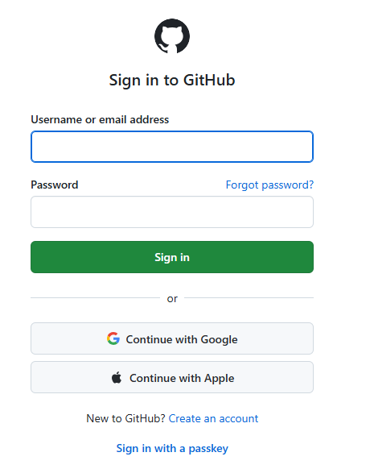
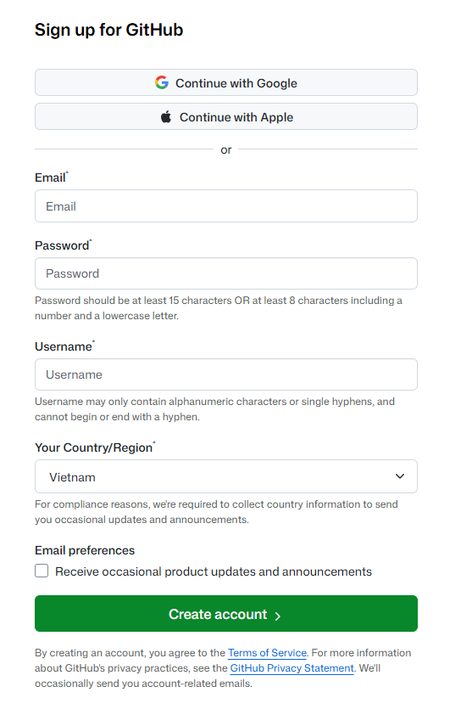

2. Creating a repository
Repository (or repo) is the “folder” where all your code should be stored. One repository should be used for one project only.
After sign in, there are two ways to create a new repository:
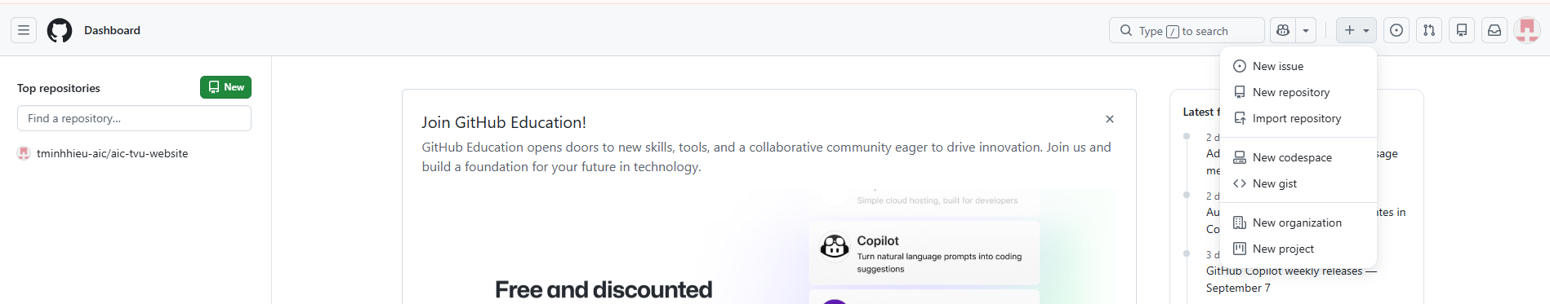
You can click on the new button on your Repositories tab, or you can press the + button on the Navigation bar:
Create your first repository by filling in the details:
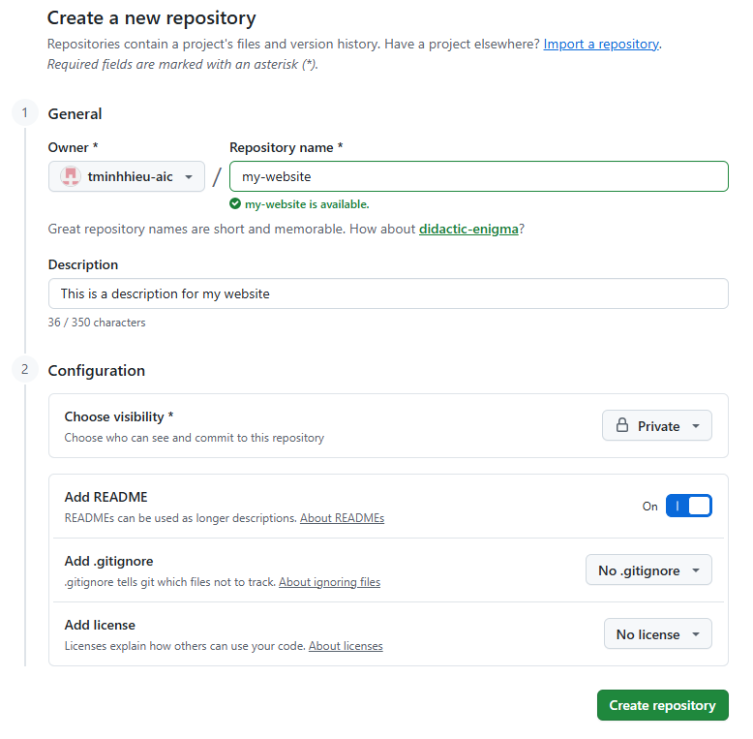
- Repository name: should be meaningful
- Description: if you use this for private purposes, you can leave it empty
- Visibility: you can choose between Public or Private
- README: the first thing visitors will see on your Repo, you can write introductions here
- .gitignore: some languages and libraries create a lot of files while building, this is used to ignore these files. For now just leave the default setting.
- License: important when you plan on using this project for commercial purposes, for now use “No license”
Your repo screen should look like this:
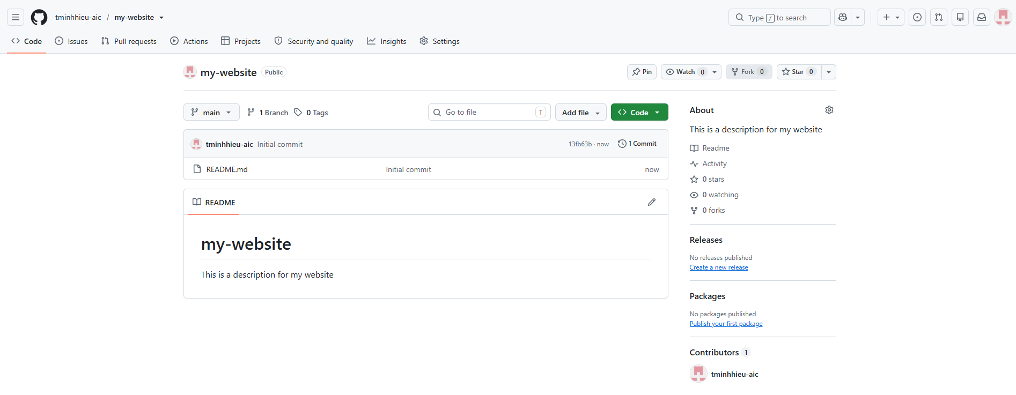

3. Cloning your project
Cloning in Github is the action of copying a version of your project to your computer.
But before that, you need to clean TERMINAL commands. You can access the terminal on your Visual Code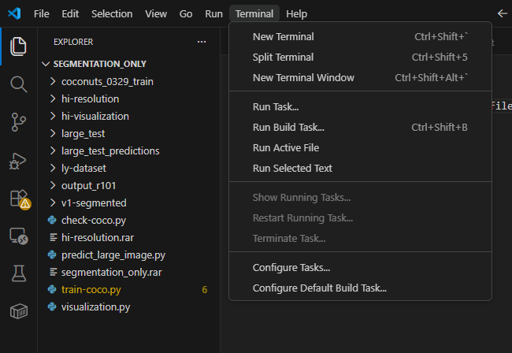
Your terminal will be located at the bottom of the screen, and look like this:
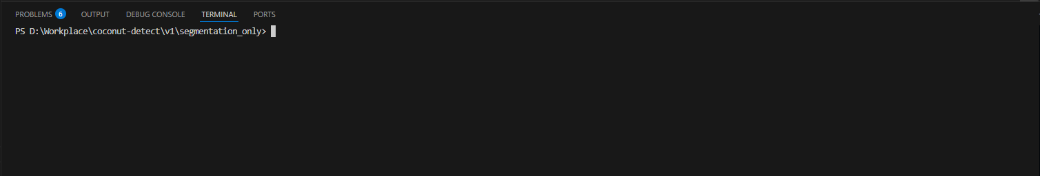
Here are some common command you need to know:
- pwd: Show current location
- ls: show content of current location
- cd: move to another folder
- mkdir: make a new folder → “mkdir newfolder” to create a folder named “newfolder”
This should be enough for now. Back to git and gitHub. To clone your newly created project to your computer, move to the folder you want using terminal.
Then, write the command:
git clone <URL to your git>
You can find your git URL in your repository:
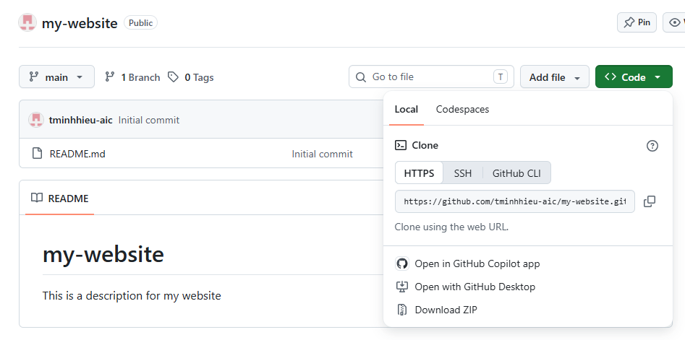
For example, my command to clone is:
git clone https://github.com/tminhhieu-aic/my-website.git
Now your project should be downloaded to the location you want. You can create new code files and work in this project folder as normal.

4. Pushing new changes
When you creating new files in this project folder, you can see that the file name is colored in green. This is the git system telling you this file is new.
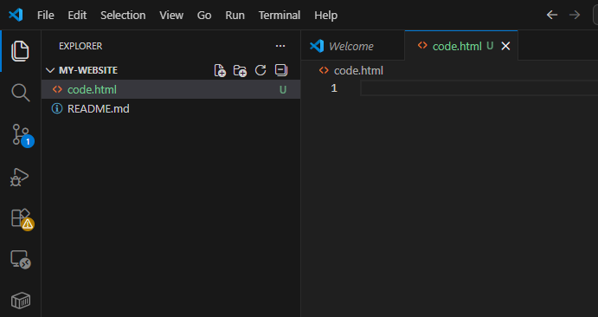
Some common color and character:
Color | Character | Git status | Meaning
💚 Green | U/A | Untracked / Added | New file that Git hasn't committed yet, or newly added file
🍊Orange | M | Modified | Existing file has been changed
🔴 Red | D/C | Deleted / Conflict | File was deleted or there is a problem/conflict
🔵 Blue | M/C | Modified/Changed | Depending on your VS Code theme, may indicate changes

After you finish your work, you should push (or upload files) to the repository. This serves as a backup method, as well as allowing your co-worker to work with your new files.
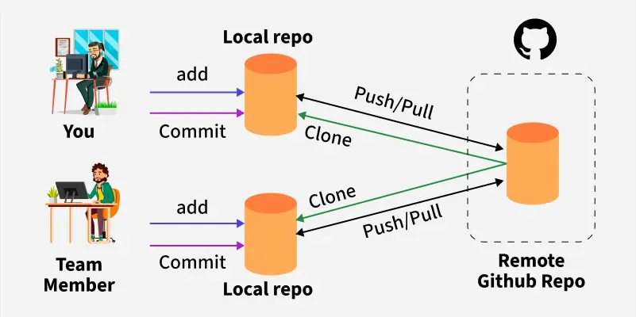
This is a pipeline (processes) of what you should do to push new changes on your repository:

4.1. Check which branch you are on:
In git, “branch” is a “version” of the code that you are working on, if you have not done anything, you will be on main/master branch (same thing, just different name based on your gitHub define).
To check which branch you are on, use
git branch
For example, I am on the main branch. It is standard that for each feature you work on, you should create a new branch for it. But for this tutorial, we will be using the main branch.

4.2. Check the files status:
To check status of all files in repository, run
git status
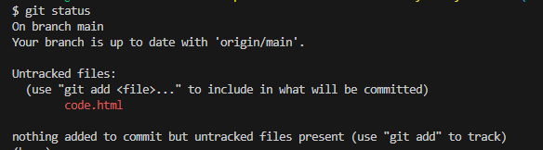
It should show you all the changes compared to your latest local repository.

4.3. Select the files to push:
From the list of files in git status, you can select which file you want to push to the remote repository.
git add <name of the file>
For example, if I only want to push the code.html file, I will run
git add code.html
You can add ALL FILES that are changed by using:
git add -A
After adding file to the list, you can check by using git status again:
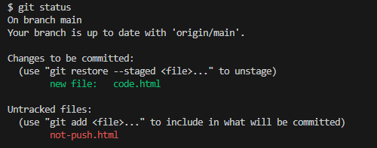
All files that you have added to the push list will be in green, while files you do not add will be in red.

4.4. Commit the files to your local repository:
You can commit (upload) the files onto your local repository using:
git commit -m “<message commit>”
The message should be between two quotation marks (“ “). This message should be meaningful, because you (and your co-workers) will commit A LOT during your real projects at work.
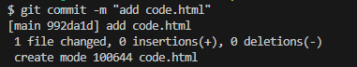
If there is no error, the screen will look like this.
Now if you refresh your repository on Github, you will see that nothing changed! That is because you only commit (push to your LOCAL repo). To push to Github repository (or called remote repository).

4.5. Push to the Github repository:
Final step: pushing changes to Github repository.
Warning: all previous steps can be undo if you make a mistake. This step CANNOT BE UNDO. You should check that everything work correctly before pushing to Github:
git push
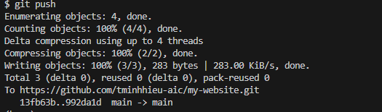
Now if you refresh your Github, your new files should be on the hub:

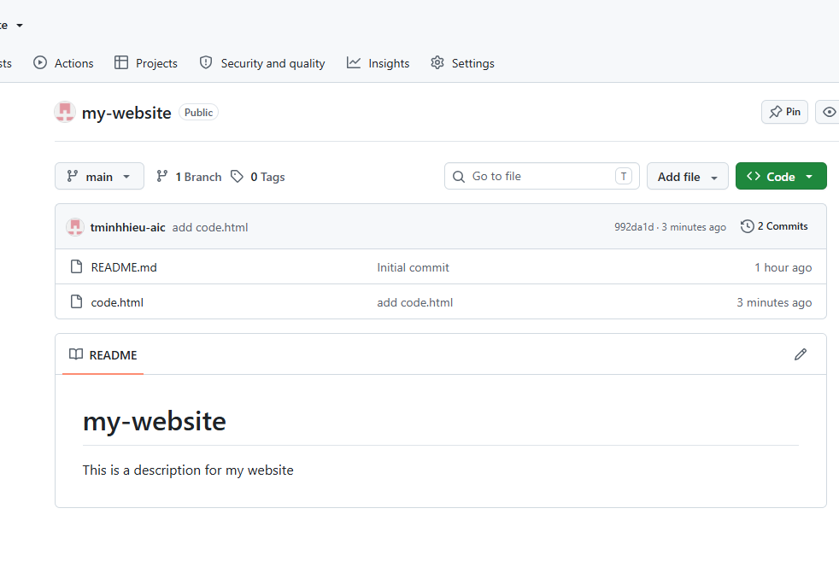
You can see the commit message, and the time of push on my new file.

4.6. Pulling changes
If you are the person to create changes, your local repository is already updated as the Github repo. But what if your CO-WORKER push instead?
Whenever you start your working day, you should PULL the newest changes on Github by running:
git pull
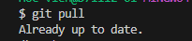
If it say “Already up to date” then your local repository is up-to-date (the same) as Github repository. If it say something else, it is pulling the newest version.
This is the very basic of Git and Github, there are other advanced commands that you can learn on your own (or ask me) when you run into problems. For now, this knowledge should be enough for you to do your final exam.

